Student Activity: Call Waiting
- On one side of the Plan Card, there is a chart on which you will record all your cellphone charges. Have this side of the chart facing your group.
- Place the Calling Cards face down in the middle of the circle. The starting team may then draw a Calling Card. This team should then record the relevant information on their Plan Card in the chart provided.
Check out these examples.
The Distance Assistance group pulls out this Calling Card:

You want to check out a new web video on your phone. You browse through 30 different pages before finding the right video.

Includes
  - 200 anytime/anywhere minutes in Canada
  - No long distance charges for calls made within Canada or from Canada to the U.S.
$30 per month
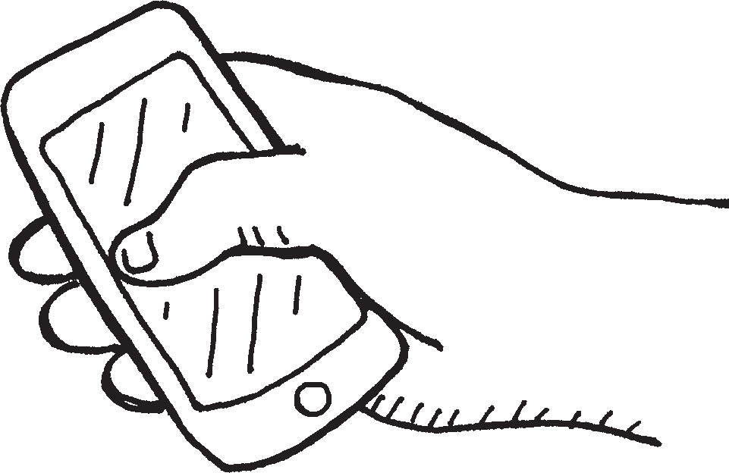
Extra Charges
  - Daytime minutes – $0.50 per minute
  - Long distance minutes – $0.60 per minute
  - Browsing – $0.25 per page
  - Downloads – $1 per download
  - Texting – $0.20 per sent/received text

Minutes Left | Call Text Download Browse | Description | Rate | Charge
200 | X | surfing 30 web pages | .25 | $ 7.50
 |  |  |  | $
 |  |  |  | $

Call Waiting Instructions
The Day and Night Delight group pulls this Calling Card:
$30 per month
Includes
• 250 daytime local minutes
- Unlimited local evenings and weekends starting at 5 p.m.
Extra Charges
- Daytime minutes – $0.50 per minute
- Long distance minutes – $0.60 per minute
- Browsing – $0.25 per page
- Downloads – $1 per download
- Texting – $0.20 per sent/received text

You call one of the group members of Text Etiquette on Friday at 7 p.m. when you are out of province. You talk for 40 minutes.

Minutes Left | Call Text Download Browse | Description | Rate | Charge
250 | X | long distance 40 min. | .60 | $ 24
The Text Etiquette group will also need to track this call:

Includes
  - 200 daytime local minutes
  - Unlimited text messaging
  - Unlimited local evenings and weekends starting at 8 p.m.
$30 per month
Extra Charges
    - Daytime minutes – $0.50 per minute
    - Long distance minutes – $0.60 per minute
    - Browsing – $0.25 per page
    - Downloads – $1 per download

Minutes Left | Call Text Download Browse | Description | Rate | Charge
160 | 3 | long distance 40 min. | .60 | $ 24
- Continue by drawing cards and recording charges until the Calling Cards are finished or the allotted time for the activity is over.
- Following the activity, each team must calculate all the charges on their bill. The group with the lowest phone bill wins.

Includes
- 200 anytime/anywhere minutes in Canada
- No long distance charges for calls made within Canada or from Canada to the U.S.
$30 per month
Extra Charges
- Daytime minutes – $0.50 per minute
- Long distance minutes – $0.60 per minute
- Browsing – $0.25 per page
- Downloads – $1 per download
- Texting – $0.20 per sent/received text

Minutes Left | Call Text Download Browse | Description | Rate | Charge
 |  |  |  | $
 |  |  |  | $
 |  |  |  | $
 |  |  |  | $
 |  |  |  | $
 |  |  |  | $
 |  |  |  | $
Plan Charge + Activation Charge |  |  |  | $ 37.95
GST/PST |  |  |  | $
TOTAL |  |  |  | $

Includes
- 200 daytime local minutes
- Unlimited text messaging
- Unlimited local evenings and weekends starting at 8 p.m.
$30 per month
Extra Charges
  - Daytime minutes – $0.50 per minute
  - Long distance minutes – $0.60 per minute
  - Browsing – $0.30 per page
  - Downloads – $1 per download

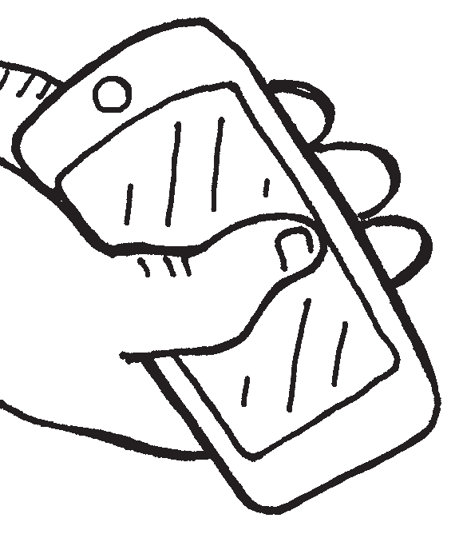

Minutes Left | Call Text Download Browse | Description | Rate | Charge
 |  |  |  | $
 |  |  |  | $
 |  |  |  | $
 |  |  |  | $
 |  |  |  | $
 |  |  |  | $
 |  |  |  | $
Plan Charge + Activation Charge |  |  |  | $ 37.95
GST/PST |  |  |  | $
TOTAL |  |  |  | $

Includes

Extra Charges
$30 per month

- 250 daytime local minutes
- Unlimited local evenings and weekends starting at 5 p.m.
- Daytime minutes – $0.50 per minute
- Long distance minutes – $0.60 per minute
- Browsing – $0.25 per page
- Downloads – $1 per download
- Texting – $0.25 per sent/received text

Minutes Left | Call Text Download Browse | Description | Rate | Charge
 |  |  |  | $
 |  |  |  | $
 |  |  |  | $
 |  |  |  | $
 |  |  |  | $
 |  |  |  | $
 |  |  |  | $
Plan Charge + Activation Charge |  |  |  | $ 37.95
GST/PST |  |  |  | $
TOTAL |  |  |  | $

Charges
- Daytime minutes – $0.50 per minute
- Long distance minutes – $0.60 per minute
- Browsing – $0.25 per page

- Downloads – $1 per download
- Texting – $0.25 per sent/received text

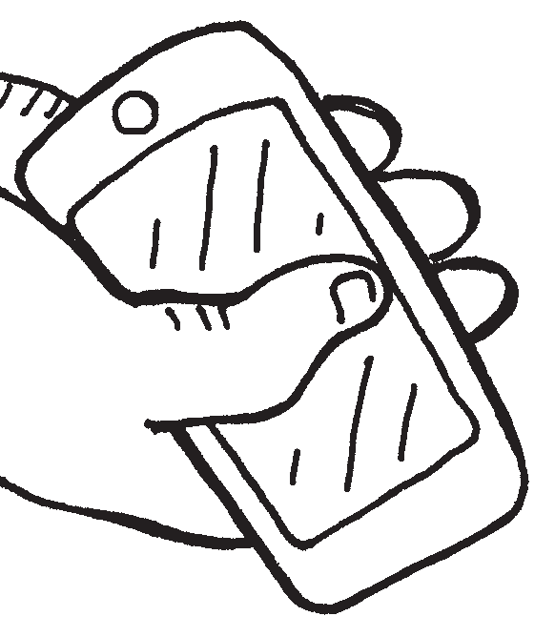

Minutes Left | Call Text Download Browse | Description | Rate | Charge
 |  |  |  | $
 |  |  |  | $
 |  |  |  | $
 |  |  |  | $
 |  |  |  | $
 |  |  |  | $
 |  |  |  | $
Activation Charge |  |  |  | $ 7.95
GST/PST |  |  |  | $
TOTAL |  |  |  | $

Includes
- 200 daytime local minutes
- Unlimited data
$30 per month
Extra Charges
- Daytime minutes – $0.50 per minute
- Long distance minutes – $0.60 per minute
- Texting – $0.20 per sent/received text

Minutes Left | Call Text Download Browse | Description | Rate | Charge
 |  |  |  | $
 |  |  |  | $
 |  |  |  | $
 |  |  |  | $
 |  |  |  | $
 |  |  |  | $
 |  |  |  | $
Plan Charge + Activation Charge |  |  |  | $ 37.95
GST/PST |  |  |  | $
TOTAL |  |  |  | $

